**Cover Page**

**Table of Contents**

**Executive Summary**

**Description of Current System**

Chris Lynch Fencing is a Montana founded growing business that has recently relocated their base of operations to Hawaii. Three years ago, they made this move because they began taking on State of Hawaii fencing contracts, which are more lucrative than stateside jobs. Currently, the business does not have a single software system to perform all of their business functions. They use QuickBooks Premiere Contractors Edition for most of the financial operations such as billing, invoicing, and general accounting tasks. However, they rely heavily on the receipting function included with the American Express Platinum card. They currently outsource their onboarding and payroll functions to a Hawaii-based company named Pro-Service. This is because of Hawaii’s extensive requirements for all employees, including health insurance and temporary disability. They have historically used spreadsheets to track their fencing materials, but the State of Hawaii contracts supply all materials, so this is no longer necessary. They currently track their equipment on an Excel spreadsheet which includes items such as purchase amount, year, make, model, VIN, sales tax, and island location. All estimating for a job is done manually on paper and then the price per square foot for each line item is entered into the State of Hawaii’s procurement system, HIePro.

**System Users**

There are three primary users at Chris Lynch Fencing. Jami Lynch, the owner/office manager of Chris Lynch Fencing is the primary user of all of the information systems. Jami is the one that collaborates with Pro-Serve for employee management, accesses HIePro for entry of contract bids, utilizes QuickBooks for accounting, maintains the company spreadsheets, and manages the receipts via the American Express app. Jami will continue to need access to all information systems for the business. Chris Lynch is the owner/project manager of Chris Lynch Fencing and primarily relies on communication with Jami for all system interaction. For example, when Chris purchases or moves inventory, he communicates with Jami who enters/updates the data in the appropriate spreadsheets. Similarly, when Chris manually computes the line-item job estimates, he passes them to Jami for input into the HIePro procurement system. Chris does use the American Express receipting app, however, and uses his phone to take pictures of all receipts. These receipts are then immediately available to Jami in the American Express App. Landon Lynch is a Crew Chief for Chris Lynch Fencing and primarily relies on communication with Jami for all system interactions. However, like Chris, he does utilize the American Express receipting app on his phone.

**Problems**

They are fairly satisfied with QuickBooks for their financial and accounting system. However, their reliance on American Express for receipt tracking poses some problems. Most importantly, only items purchased with American Express are being tracked and secondly, there must be manual intervention to match these receipts to the corresponding expenditures in QuickBooks.

As the business continues to grow, they have jobs spread across many Hawaiian Islands, necessitating storage facilities on each island to house their equipment such as trucks, trailers, tractors, drills, tools, tents, etc. It is impossible for the project manager and crew chief to know what equipment is on each island at all times and they have to communicate with the office manager to locate the information on her spreadsheet. It would be nice if they could access their equipment inventory in real time from their phones. Ideally, when these crew members purchase or move a piece of equipment, they could access the inventory system and update it accordingly. This would save the office manager a significant amount of time trying to keep this spreadsheet up to date. Additionally, the office manager has to use this spreadsheet to do calculations for yearly sales tax owed on each piece of equipment. It would be nice if the inventory tracking system could do this for her.

As the business continues to grow, Chris is also spending more time doing manual estimating and calculations for jobs. It would be ideal if he had a system that would assist him with job estimation.

**Existing Spreadsheet Diagram 1**

**Needs Assessment**

Their primary need is equipment inventory. They need a system that will allow them to track equipment inventory and customize the details that they need to track. It’s important for them to track purchase price, Year, Make, Model, Body Type, VIN number, Cost of new sales tax, Sales tax. Purchase cost after trade in, and Island. It’s important that this system allows the Project Manager/Crew Chief to be able to access this from their mobile devices to locate inventory and enter inventory movement. This would free up a great amount of time currently lost in communicating inventory actions between the Project Manager/Crew Chief and the Office Manager. This will also lessen the burden of keeping the spreadsheet updated solely by the Office Manager. This system also needs to be able to calculate the cost and depreciation of equipment.

Their second highest need is estimating a job and sending the bid. This is mainly done by the project manager; he needs to be able to visit a job site and ideally using a GPS system determine the overall linear Ft or miles of fence needed. To go along with this, it will be able to assist him in calculating the milage cost and man hours. The system needs to be customizable to assist him in estimating additional costs depending on the job such as the number of gates, line clearing, helicopter flight time, and travel time.

Their last need determined at this time is to help with tracking receipts. The Office Manager needs to be able to efficiently track receipts of purchases. Upon a deeper dive into the functionality of QuickBooks she would to be able to have a better receipt tracking system if she were to upgrade QuickBooks Desktop to QuickBooks Online.

**Diagram 1: Existing Equipment Inventory System**

**Chris Lynch Fencing Data Flow Diagram 1**

**Diagram 1.1: Existing Estimating System**

**Chris Lynch Fencing Data Flow Diagram 1.1**

**Diagram 1.2: New System**

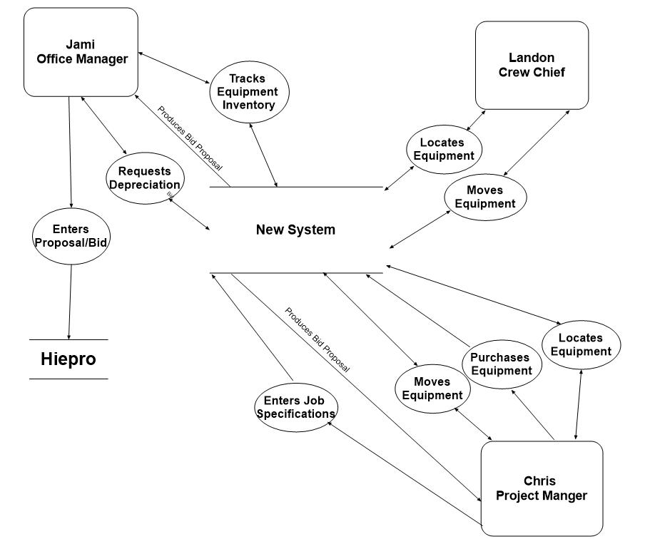

**Chris Lynch Fencing Data Flow Diagram 1.2**

**User Stories**

Chris is the owner/project manager, he wants to measure a job with or without GPS and generate lost estimates and conveniently send a proposal and relieve signed consent saving time out of office.

Chris is the owner/project manager, he wants to easily track equipment inventory as to which island equipment is in, decreasing the time tracking equipment down.

Jamie is the owner/ Office Manager, she wants to be able to track equipment location from island to island and location to location along with overall condition, so that new equipment is purchased and delivered to sites as needed.

Jamie is the owner/ Office Manager, she wants to find a less expensive receipt tracking system, thus saving the business overhead.

Chris is the owner/ project manager, he wants to move equipment from one island to the other or one job site to another and wants to enter this in a system using mobile app, this allows Jamie to follow equipment remotely.

Landon is the crew chief; he wants to easily input equipment location by island or site with his mobile to increase efficiency or equipment inventory.

**Alternatives**

**Alternative #1: Sortly**

Sortly is a cloud-based software that is for inventory management but, it does not have any options for estimating. Sortly is user-friendly software designed for businesses of all sizes to track and organize their inventory easily. It is valued for its simplicity and flexibility, making it a good fit for industries like construction management.

**Software:** Windows 10 or later

**Web Browser**: Latest version of Google Chrome, Microsoft Edge, Safari, and Firefox

**Processor:** A standard multi-core processer (Intel i3 or higher and equivalent AMD processor)

**Memory:** At least 4 GB for general usage but 8 GB or higher is recommended.

**Hard Drive:** Minimal storage is required locally, a system with 64 GB, or more is sufficient.

**Network Controller:** A stable internet connection is crucial for syncing data to the cloud.

**Data Protection:** Does not require extensive local protection, but ensure the device has basic antivirus software and uses secure passwords.

**Mobile Device:** IOS and Android compatible

**Cost:**

* **Free:** $0/mo
  + 1 user licenses
  + Track up to 100 unique items.
* **Advanced:** $24/mo ($288/Year)
  + 3 users licenses
  + Track up to 500 unique items.
* **Ultra:** $74/mo ($888/Year)
  + 5 User licenses
  + Track up to 2,000 unique items.

**Cost Estimate:**

Of the three options of Sortly the free option only allows for 1 user and 100 unique items of which they will need at least 3 users and have over 100 items to track. The Ultra version has a much higher cost per month putting it closer to my other two alternatives without the added benefit of measuring/estimating. That leaves Sortly’s advanced option which is listed at $24/month or $288/year with no upfront purchase cost. After speaking with the two owners of Chris Lynch Fencing, Jami feels she spends 4 hours per week on inventory and Chris and his crew close to 6 hours per week tracking and getting equipment. With the aid of an inventory tracking system Jami feels she could possibly decrease her time by as much as 50%, and Chris feels he could decrease their time by 2 hours. I used an hourly wage for Jami of $45 per hour and an average for the crew of $37.50 per hour.

**Conservative Estimate:** 1 hour saved by both Jami and the crew.

1 hour at $45/hour = $45

1 hour at $37.50/hour = $37.50

Totals $82.50/week saved * 4 weeks = $330/mo or $3,960/year

$3,960 - $288 = $3,672 savings per year

**Optimistic Estimate:** 2 Hours saved by both Jami and the crew.

2 hours at $45/hour = $90

2 hours at $37.50/hour = $75

Totals $165/week saved * 4 weeks = $660/mo or $7,920/year

$7,920 - $288 = $7,632 savings per year

**Alternative #2: FieldBin**

FieldBin is another cloud-based software service. It provides customer communication, Time tracking, estimates and quotes, inventory management, invoicing, scheduling and dispatch, and reporting. It is compatible with QuickBooks, making accounting easier. FieldBin also allows you to measure jobs by using GPS. FieldBin has specific trade options that you can use to specific your service including fencing. The design is simple and accessible for small to mid-size business owners without extensive technical expertise. It also allows users to access and manage tasks remotely via mobile apps.

**Software:** Windows 10 or later

**Web Browser**: Latest version of Google Chrome and Safari

**Processor:** A standard multi-core processer (Intel i5 or higher and equivalent AMD processor)

**Memory:** At least 8 GB to handle simultaneous operations

**Hard Drive:** Relies on cloud storage, a device with 128GB or more is ideal for storing.

**Network Controller:** A stable internet connection is crucial for real-time updates in the field

**Data Protection:** Ensure devices have up-to-date antivirus software and encryption tools along with secure password management.

**Mobile Device:** IOS and Android compatible

**Cost:**

* **Basic:** $19/mo ($228/Year)
  + 1 user
* **Sync:** $65/mo ($780/Year)
  + 1-5 users
* **Build:** $99/mo ($1,188/Year)
  + More than 15 users

**Cost Estimate:**

Of the three options available on this platform, I see the middle, Sync, as being the most viable for Chris Lynch Fencing. The basic does not allow for enough users, while build is similar to Sync, just having priority support, for 33% more per month. Sync allows for 1-5 users for $65 per month or $780 per year, again with no upfront cost. This platform would help similar to Sortly with inventory but has the added advantage of measuring/estimating for Chris. Using the GPS sum for measuring and not having to manually figure cost Chris feels he could save up to 6 hours per job depending on job size. I used 2 hours of job time for a conservative estimate and 4 hours for optimistic, with an hourly wage for Chris at $95/hour. I plan on them bidding 8 large Hawaii state jobs per year.

**Conservative Estimate:**

2 hours at $95/hour = $190

$190 * 8 jobs = $1,520/year

$1,520 (estimating/bidding) + $3,960 (inventory from alternative 1) = $5,480/year

$5,480 - $780 = $4,700 saving per year

**Optimistic Estimate:**

4 hours at $95/hour = $380

$380 * 8 jobs = $3,040/year

$3,040 (estimating/bidding) + $7,920(inventory from alternative 1) = $10,960/year

$10,960 - $780 = $10,180 savings per year

**Alternative #3: Fence Cloud**

Fence Cloud is a specialized cloud-based software designed for the fencing industry. It provides tools to streamline operations, such as estimating materials, creating job sketches, managing customer relationships, tracking project progress. With features like preloaded supplier database, material templates, and integration with tolls like GeoDraw. Advantages of Fence Cloud include its easy use, with customizable options and automatic routine tasks. Features like duplicating estimates, syncing with external calendars, and integrated communication tools. It is designed specifically for the fencing industry and is adaptable for many fence types.

**Software:** A modern web browser is required, compatible with Windows, macOS or Linux operating systems.

**Web Browser:** Latest versions of Google Chrome, Mozilla Firefox, Microsoft Edge, or Safari

**Processor:** A multi-core processor Intel Core i5 or equivalent.

**Memory:** At least 8GB of RAM for desktop; 16GB is recommended.

**Hard Drive:** Minimum 256 GB SSD; 512GB or higher if managing related project files locally.

**Network Controller:** A standard Ethernet or Wi-Fi supporting modern standards. 802.11ac or better for Wi-Fi

**Data Protection:** Use antivirus and anti-malware software to ensure access to the platform. Ensure data transmitted between your device and Fence Cloud’s servers is encrypted. While Fence Cloud most likely handles data backups, maintaining local backups of critical files or estimates can add a layer of protection.

**Hardware:** Dual Monitors are useful for project managers or estimators working with multiple windows but are not required.

**Mobile:** IOS and Android compatible

**Cost:**

* **Essential:** $175/mo ($2,100/Year)
* Allows 1-3 Users
* 2 Company Profiles
* Full Feature Suite
* **Professional:** $299/mo ($3,588/Year)
* Allows 4-10 Users
* 5 Company Profiles
* Full Feature Suite

**Cost Estimate:**

Fence Cloud would allow for similar benefits to the business as that for FieldBin. It has the added advantage of allowing for growth with up to 10 users if you are going with the professional package. I did not look at the less expensive essential as it is identical to FieldBin’s platform for $1,000 per year more. So, using the same numbers as alternative number 2 with the professional cost my two estimates are as follows.

**Conservative Estimate:**

$5,480 - $3,588 = $1,892 savings per year

**Optimistic Estimate:**

$10,960 - $3,588 = $7,372 savings per year

**Current Hardware: Chris Lynch Fencing**

* **Software:** Windows 10 Pro
* **Web Browser:** Google Chrome
* **Processer:** Intel(R) Core(TM) i7-10510U CPU @ 1.80GHz 2.30GHz
* **Memory:** 8 GB
* **Hard Drive:** 461 GB
* **Network Controller:** Standard Wi-Fi
* **Data Protection:** McAfee
* **Mobile Devices:** Android

**Similar Business Research**

I was able to contact and discuss other business models with two other fencing contractors, FenceCrafters and Helena Fence. Both companies were interested in similar software solutions for aiding with inventory tracking and with improving job estimating. They were unable to give feedback on any of the three software platforms I have researched as they are not using them. They are similar to Chris Lynch Fencing in that they both have functioning user friendly websites and rely on QuickBooks for much of their business and payroll tracking. They develop their own spreadsheet tracking systems for fencing and equipment inventory and still do a lot of their measuring and estimating of jobs by plugging in what is needed and calculating it themselves.

Although I was not able to obtain firsthand knowledge of these systems, their interest in these systems gave credence to my belief business and financial benefits could be tangible with their implementation.

**Financial Analysis / Feasibility**

|  |  |  |  |  |
| --- | --- | --- | --- | --- |
| **Project Phase** | **Task** | **Start Date** | **End Date** | **Duration** |
|  |  |  |  |  |
|  |  |  |  |  |
|  |  |  |  |  |
|  |  |  |  |  |
|  |  |  |  |  |
|  |  |  |  |  |
|  |  |  |  |  |

**Time and Cost Estimates**

**Recommended Alternatives**

**Objectives and Benefits of Proposed System**

Summary Benefits

Tangible Benefits

Intangible Benefits

**System Scope**

**Functional Requirements**

**Conclusion**